**DELUXE PEDESTAL FANS:**

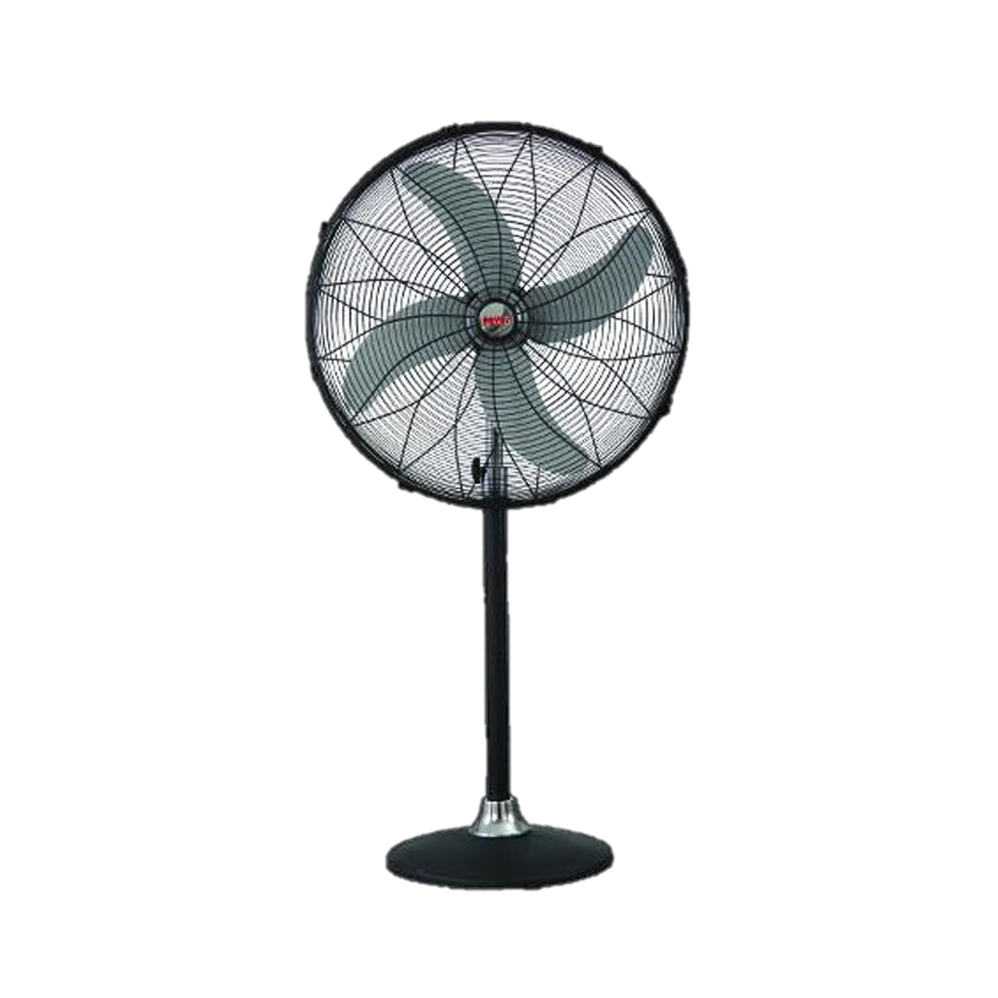

**Price: 14,495.00**

Deluxe Pedestal Fans are a premium cooling solution, offering a perfect blend of style, comfort, and performance. With their sturdy and adjustable pedestal design, these fans provide focused airflow and can be tailored to suit various ceiling heights and room layouts. Equipped with powerful motors and aerodynamically designed blades, Deluxe Pedestal Fans ensure efficient air circulation, making them ideal for large rooms, offices, and commercial spaces. Their sleek and modern design adds a touch of sophistication, while their quiet operation and low power consumption make them a practical choice..

**Key features of deluxe pedestal fans include:**

* **Adjustable Height:** Allows customization of airflow height for different room sizes and preferences.
* **Oscillation:** Ensures air circulates across a wide area, providing even cooling**.**
* **Multiple Speed Settings:** Offers flexibility to adjust airflow intensity, typically with 3-5 speed options.
* **Remote Control:** Convenient for adjusting settings from a distance.
* **Quiet Operation:** Designed with noise reduction features for a more peaceful environment.
* **Timer Function:** Enables setting a timer for automatic shut-off, saving energy.
* **Tilt and Angle Adjustment:** Allows for direction control of airflow.
* **Energy Efficiency:** Often built to consume less power, reducing electricity bills.
* **Stylish Design:** Aesthetic designs that blend well with modern interiors.
* **Enhanced Durability:** Built with high-quality materials for long-lasting performance.